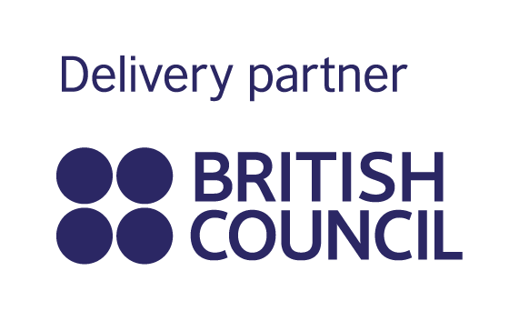
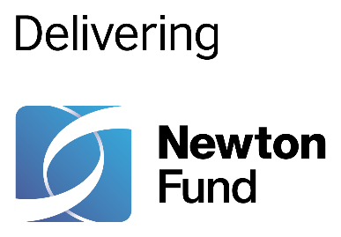
In partnership with
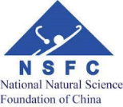

UK-China Researcher Link Workshop

Title: Rethinking Healthy City in the post-COVID19 Era: Exposure, Mobility and Inequality

Dates and venue: 1-5 November 2021, Online

- UK Principal Applicant: Dr Jianquan Cheng, Manchester Metropolitan University
- Partner Country Principal Applicant: Prof Suhong Zhou, Sun Yat-sen University
- Discipline: Geography, Planning, GIS, Environment, Public Health, Sociology

The programme, Newton Fund Researcher Links provides opportunities for early career researchers from the UK and internationally to interact, learn from each other and explore opportunities for building long-lasting research collaborations.

The workshop will produce multiple outputs including a review and evaluation report. ECRs will benefit from the interactive discussion, networking and mentoring activities through constructive ways.

As part of this programme, we are now recruiting early career researchers to participate in the above workshop. The workshop will provide a unique opportunity for sharing research expertise and networking. During the workshops early career researchers will have the opportunity to present their research in the form of short oral presentation and discuss this with established researchers from the UK and China. There will be a focus on building up links for future collaborations and participants selected on the basis of their research potential and ability to build longer term links.

The Newton Fund and National Science Foundation of China will cover the costs related to the participation to the workshop; however participants will be responsible for making all the necessary arrangements. The British Council accepts no responsibility for any problems which may occur or any other issues participants might experience.

Application and Deadline

The full application below must be completed and submitted by 30 October 2021 to J.Cheng@mmu.ac.uk.

Eligibility Criteria

- Applications must be submitted using the Researcher Links application form
- Application must be submitted before the above deadline

- Participants must be Early Career Researchers:

Early Career Researchers are defined as holding a PhD (or having equivalent research
experience) and having up to 10 years post-PhD research experience. They are
equivalent to the ‘Recognised Researcher’ and sometimes ‘Experienced Researcher’
categories in the EU framework for researchers’ careers.
They have academic expertise and interests in one of these areas:
Environmental health, healthy planning and governance, health GIS, digital health,
health/medical geography, sport geography, urban big data, and urban study.

- Participants must have a research or academic position (a permanent post, research
contract, or fellowship etc) at a recognised research institution in the UK.
- Please note that participants are expected to attend all sessions of the workshop.

Quality Assessment

- Experience and relevance of the applicant’s research area to the workshop
- Motivation and contribution to the aims of the workshop
- Description of the long-term impact expected through the participation in the workshop
- Ability to disseminate workshop’s outcomes

Notification of results
Applicants will be notified by email prior to the workshop.

Equal Opportunities

Equal opportunities and diversity are at the heart of the British Council’s cultural
relations ambitions. While recognising that some research fields are dominated by one
particular gender, efforts will be made to work towards an equal gender balance,
promote diversity. Applicants will not be excluded on the basis of ethnicity, gender,
religious belief, sexual orientation, or disability.

Acknowledgement
This work was supported by a Researcher Links grant, ID [2020-RLWK12-10144], under the Newton-China Fund partnership. The grant is funded by the UK Department for Business, Energy and Industrial Strategy and National Science Foundation of China and delivered by the British Council. For further information, please visit https://www.newton-gcrf.org/.
Workshop Application Form
- Applicant
Name and title
Gender (for statistical purposes. This will not affect choice of participants)
Position and institution
Postal address
Email
Phone number

1. Brief CV (academic career, publications, markers of esteem, and any other relevant information) – no more than ½ page of A4

2. Abstract - Please give a summary of your area of research

3. Please describe your motivation for attending the workshop and how the workshop matches your professional development needs
4. Please describe the expected impact of your participation on your personal and professional development, including your ability to work internationally

5. Please indicate how you will disseminate the outcomes of the workshops and the new knowledge/skills you have acquired

6. Workshops will take place in English as standard. Please indicate your ability to work and communicate in English (Note, translators may be provided if necessary)
Native speaker |  | Good
Excellent |  | Need support

7. Please use this space to give any additional information that you feel is relevant for the application.

Thanks for your support!
Dr Jianquan Cheng, J.Cheng@mmu.ac.uk

