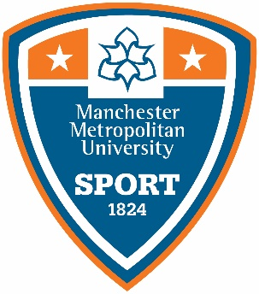

START A NEW SPORTS CLUB

A sports club is a sporting group (recognised as a sport by any of the governing bodies or British Universities & Colleges Sport).

The steps to becoming an affiliated club:

- We’ll respond to your application within 10 working days

- We will ask the club to visit the MMU Sport office for a meeting with the relevant Sport and Club Development Officers within 14 days of an e-mail response

- We will look to run your session with our Sports Development department over a 6-10 week period

- The activity will be under review for that 6-10 week period to identify how we can engage more students

- After the review period, we will work with the student leaders to decide how best to progress the club (BUCS club, Non-BUCS club, participation session, active campus - with paid activator - or setting up a campus league).

- If the decision is to become a BUCS or Non-BUCS club, the club needs to be self-sufficient for two terms before becoming affiliated and gaining access to additional funding

- If they decide to stay within participation or an active campus session, the Sports Development team will work closely with the student leaders to grow their sport and enhance playing opportunities both internally and externally

Please complete the following details and e-mail to: sport@mmu.ac.uk

Name:

Email address:

Mobile number:

Student number:

What sports club do you want to start?

Governing Body link:

Purpose for starting the club:

Aims and objectives of the club:

Finances involved with starting up club:

Where do you see the club fitting in?
- 6-10 weeks free sport, aimed at participation with NO coach & a student-led session

- 6-10 weeks coached session with a small fee

Is this an additional team?
YES/NO
Details of two students wanting to start up club:
• Name:

• Email address:

• Student number:

• Name:

• Email address:

• Student number:

• List of students interested in club - please give the students' name and student numbers (10 students minimum.)
Students:
1.
2.
3.
4.
5.
6.
7.
8.
9.
10

Please email your form to sport@mmu.ac.uk and we will action as quickly as possible (normally within 14 days during term time).
Thanks for completing the form. We only collect the information you tell us for legitimate purposes and to fulfil your request and/or to deliver our services to you (e.g. to process your query).

For further information on how we manage and store your personal data, please read our privacy policy.

