STANDARD OPERATING PROCEDURE

Reference Number | MMUHTA_002
Title | Adverse Event Reporting
Effective Date | 30th January 2023
Review Date | 2nd March 2025
Superseded Version Number & date | V1.2 2nd March 2023
Author | Glenn Ferris
Reviewer | Liam Hanson
Authorisation | Designated Individual  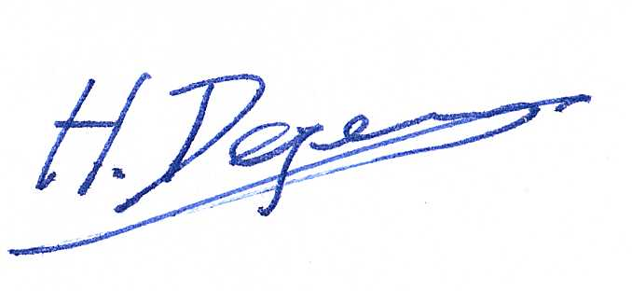  Professor Hans Degens

Background
The University has introduced a quality management system for the governance of the acquisition, storage and use of human tissue.

This system will ensure that all work is carried out to the highest standard and that the University complies with the licensing obligations of the Human Tissue Act (HTA, 2004).

This SOP forms part of a suite of SOPs (MMUHTA_001 – MMUHTA_019) that support implementation of the quality management system and should be used as directed in Manchester Metropolitan University’s HTA Code of Practice.

Purpose
The purpose of this SOP is to set out a standard template for reporting adverse events that fall under the Human Tissue Act (2004).

Human Tissue Definition
Any, and all, constituent part/s of the human body containing cells.

Scope (of this SOP)
Reporting adverse events related to relevant material in Manchester Metropolitan University. Adverse events and incidents are defined below.

Adverse Event
Any event, which has resulted in a deviation from the HTA MMU Code of Practice, SOPs and their associated policies and procedures.

Definitions

Adverse Event
Any event that:
- Caused harm, or had the potential to cause harm, to staff or visitors.
- Led to, or had the potential to lead to, a breach of security of the premises and the contents contained therein.
- Caused harm, or had the potential to cause harm, to stored human tissue (including loss).
- Gave rise to an internal inquiry.

Incident
Any untoward event or sequence of events:
- That caused, or has the potential to cause damage, harm, or a direct negative impact to an organisation’s business, security, reputation, facilities, personnel, safety, health and environment
- Where an important policy, procedure or practice was not followed by staff leading to detriment or the potential detriment of the above

Adverse events can be graded from catastrophic (Level 5) down to a near miss (Level 0).

All adverse events should be reported so that preventative action can be taken. This SOP is written specifically to cover adverse events involving human cells or tissues and should be described on a form as below. The university also has an SOP named Protocols Deviations, Violations and Adverse Event Reporting (MMU-RKE SOP 011) that covers other adverse events.

Samples lost through an adverse event should be removed from item tracker noting the sample was lost through an adverse event, selecting the most appropriate description of the adverse event from the list below:

- Freezer Failure
- Improper Sample Handling
- No Consent
- Power Failure – Building
- Power Failure – Isolated Sockets
- Transport Failure
- Unidentifiable Sample
ItemTracker should be updated promptly following the loss of samples, in situations where there is a delay between the adverse event and the removal of samples from the ItemTracker system the date of the adverse should be noted by filling in the appropriate required field. The aim is to rectify the adverse within two weeks of the event.

When reporting to adverse events relating to freezer failure and/or loss of power to storage freezers, the Tutela Monitoring System (MMUHTA_015) should be consulted and event reports downloaded every six months and stored on the HTA SharePoint within the Adverse Events folder.

Version Control

Version | Reason for change | Date
1.0 | N/A | 10th June 2021
1.1 | A new SOP was added to the suite therefore writing changed to state ‘SOPs (MMU-HTA001 – MMU-HTA016)’ rather than SOPs (MMU-HTA001 – MMU-HTA015) | 25th November, 2022
1.2 | Changed writing to state ‘SOPs (MMU-HTA001 – MMU-HTA018)’ rather than SOPs (MMU-HTA001 – MMU-HTA016) | 30th January, 2023
1.3 | Author & Reviewer fields added to title table + changed writing to state ‘SOPS (MMUHTA_001 – MMUHTA_019)’ rather than SOPs (MMU-HTA001 – MMU-HTA018)  Details added for reporting samples lost through adverse event on the ItemTracker database + Steps given for retrieval of adverse events logs from Tutela system + minor grammatical & formatting changes | 2nd March, 2023

