STANDARD OPERATING PROCEDURE

Reference Number | MMUHTA_004
Title | Transport Of Human Tissue
Effective Date | 30th January 2023
Review Date | 2nd March 2025
Superseded Version Number & date | V1.2 2nd March 2023
Author | Glenn Ferris
Reviewer | Liam Hanson
Authorisation | Designated Individual  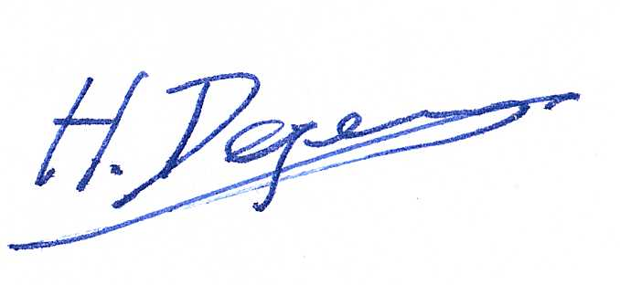  Professor Degens

Background
The University has introduced a quality management system for the governance of the acquisition, storage, and use of human tissue.

This system will ensure that all work is carried out to the highest standard and that the University complies with the licensing obligations of the Human Tissue Act (HTA, 2004).

This SOP forms part of a suite of SOPs (MMUHTA_001 – MMUHTA_019) that support implementation of the quality management system and should be used as directed in Manchester Metropolitan University’s HTA Code of Practice.

Purpose
The purpose of this SOP defines the correct procedure for arranging and conducting transfer of HTA relevant material between Manchester Metropolitan University buildings and to third parties in order to comply with the licensing obligations of the HTA 2004.

Human Tissue Definition
Any, and all, constituent part/s of the human body containing cells.

Scope (of this SOP)
All human tissue transferred to or from Manchester Metropolitan University where Manchester Metropolitan University is responsible for arranging the transport of the tissue. This SOP does not apply to tissue transferred to Stericycle (https://www.stericycle.co.uk/en-gb) for disposal.

Transport may be undertaken by a member of university staff, post-graduate student or by an approved courier.

The scope of this SOP is limited to the physical transfer of tissue. Procedures associated with documentation of the process can be found in SOP MMUHTA_003 (Material Transfer).

Procedure

Material Transfer Agreement
The University MTA can be obtained from the RKE contracts team (RKE-Contracts@mmu.ac.uk) and a template is attached to SOP MMUHTA_003.

Where material transfer is needed, University staff should explicitly agree the terms and conditions concerning the materials exchanged in a Material Transfer Agreement (MTA). All human tissues and cells classified as relevant material can only be transferred under the terms of the MTA.

Where a request is received for release of tissue for use in research with current ethical approval, and where the person/laboratory holding the tissue is not directly involved in the research, the custodian of the tissue must obtain confirmation in writing that there is ethical approval, and that consent/consent exemption is in place. This should be recorded on the form in Appendix 1 if transferred for projects with NHS ethical approval. An MTA is always required for a transfer to a third party, if that third party is not part of a study.

An MTA may be used for the transfer of material as part of a research project, if this is considered appropriate by the DI; for example, to protect intellectual property rights, or if transferring to another country. Legislation may be different in the receiving country and an MTA will ensure that the conditions of the transfer of the conditions are adhered to.

Researchers transferring material must contact the RKE contracts team (RKE-Contracts@mmu.ac.uk) who will assist you with the Material Transfer Agreement. If changes are requested by the other party, the RKE contracts team must also be informed for negotiation. Where this is the case, the DI should also be informed and updated on the progress.

The draft agreement should be forwarded to the recipient and the custodian of the material to be agreed. When both parties agree on the terms of the MTA, the original will be signed by the DI, then by the Director of Research and Knowledge Exchange before it is sent to the recipient. The University will sign more copies upon request. An authorised recipient countersigns the original wet ink version of the MTA, keeps a copy for their records then returns the original to the DI. For all MTA signatures, electronic signatures are acceptable, but original signatures and official stamps of the receiving and sending institution are preferable. A copy is then sent to the researcher for their records.

When material is transferred onto the university site, an ‘incoming’ MTA (as provided by the supplier) must be sent to the DI for review by the legal team. The incoming MTA must be signed by the DI and will be stored with the DI.

The researcher responsible for transferring or receiving transferred relevant material must keep his/her own records detailing which samples have been transferred, where the samples have been transferred to/from and dates of their sample transfer.

Any queries related to the transfer of relevant material should be directed to the DI.

Transfer of samples – packaging
The total packaging must include:
- A watertight, leakproof primary receptacle.
- A watertight, leakproof secondary packaging.
- Primary and secondary packaging must be able to retain their integrity at the temperature of transport.
- Outer packaging of sufficient strength for its capacity, mass and intended use.

For transport at ambient temperature, the primary receptacle should be plastic, metal or glass. If screw caps are used, they should be reinforced with adhesive tape to ensure a leak-proof seal.

Containers, boxes, and labels for human tissue transfer can be purchased from general laboratory suppliers.

For transport in dry ice, the dry ice should be placed around the secondary packaging (whilst wearing freezer gloves and goggles), and the secondary packaging and the outer packaging must allow the release of carbon dioxide gas to avoid the build-up of gas and potential rupturing of packaging or explosion.

Transfer of samples – Labelling and paperwork
Before samples are transferred, the following information should be included on the label

Sample Reference Number:
Tissue Type:
Details of medium/preservative if applicable:
Date of packing:
UN 3373 warning label
(https://www.tnt.com/dam/tnt_express_media/global_media_library/images/ppdownloads/2015_Guidance_Document_for_regulations_and_restrictions_UN3373_Jan2014.pdf)

Paperwork, including a list of contents, must be placed in waterproof packaging, and placed between the secondary packaging and the outer packaging. Labels on the primary and secondary packaging should be waterproof and, where handwritten, should be in permanent black ink. Labels on the outer packaging must be durable, legible, and clearly visible. They should contain the delivery address and the senders’ details. If transporting in dry ice, the words ‘DRY ICE’ should be clearly visible on the outside of the package.

A copy of the signed and countersigned MTA must accompany all human material released from the HTA licenced site. A copy of the donor consent form(s) should remain at the site; however, a copy of the consent form may be sent to the third party upon request, but only if this does not contravene donor confidentiality or the terms of the ethics approval.

Transfer of samples – Transport
It is important that researchers check that the Courier SOPs are in place to ensure compliance with the Human Tissue Act (2004) and any other appropriate legislation, ensure integrity and security of the sample, and the respect for the dignity of the donor.

Transport of human tissue samples by air requires additional documentation and, if transporting samples in dry ice, additional regulations must be adhered to.

Samples which require storage at different temperatures should be packaged separately.

All persons undertaking any role in the transport chain should be properly trained to carry out their responsibilities to the required standards. They must appreciate the risks involved and have a detailed understanding of the relevant regulations. The level of training required varies but should be commensurate with the role and the associated responsibilities and must be recurrent to take account of the changes in the regulations.

Transport of human tissue by university staff and/or students can only be undertaken if the risk associated with the transfer has been evaluated as acceptable via a university risk assessment at the Faculty level.

The PI must be satisfied that procedures to be put in place to minimise risk are adequate and that the residual risk is acceptable.

The risk assessment should include consideration of the following:
- Personal risk to the individual undertaking the transfer
- Risk to the public during transfer (chemical and biological hazard)
- Integrity of the sample
- Patient confidentiality
- Individuals involved in the transfer of human tissue are reminded that transfers should respect the dignity of the donor.

Undertake and document a risk assessment of the proposed method of transport:
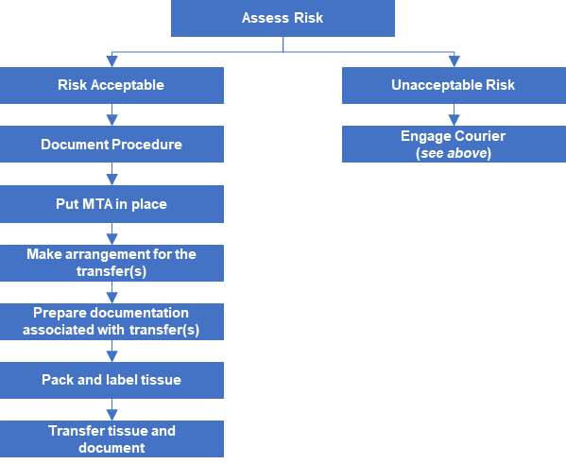

If transporting in dry ice in a standard car, as opposed to a commercial carrier such as DHL, then goods should not be transported in the same driving space that the driver/passengers occupy, and when opening the boot compartment to retrieve a dry ice container the area should be allowed to ventilate to ensure any build-up of CO₂ gas dissipates before leaning into the area.

Transfer of samples – safety
Be aware of the weight of the package, do not overfill.

When packaging/transporting in dry ice the following safety points should be noted:
- Avoid contact with skin and eyes
- Never handle with bare hands, use insulated gloves, and use tongs to handle blocks of dry ice. Goggles are recommended
- Obtain dry ice in the form and size in which it will be used. Do not attempt to saw or break a block into smaller pieces
- Transport in a well-ventilated vehicle
- Never store in an airtight container
- Do not use in confined areas – the CO₂ vapour can cause rapid suffocation
- Do not place dry ice on a tile or laminated countertop
- Dispose of the dry ice by allowing it to sublimate in a well-ventilated area where no build-up of CO₂ vapour can occur

Do not dispose of dry ice in sewers, sinks or toilets as the extreme cold can damage sink disposals and pipes.

Appendix 1

Agreement for transfer of Archival tissue for projects with NHS ethical approval

- I confirm that the samples have been requested for a specific research project with ethical approval from an NHS Research Ethics Committee (REC).

Project Title:
REC approval number:
Project start date:
Project finish date:

- I confirm that (initial as appropriate)

Patient(s) has/have given consent for the samples to be used in this research project.
Consent exemption has been granted by the NHS REC

- I agree to abide by all relevant UK legislation pertaining to the use of human tissues and data including the Human Tissue Act (2004) and its Codes of Practice, and the Data Protection Act (1998).

- I agree to follow good clinical and laboratory practice in handling the sample(s).

- I agree to return the samples as soon as they are no longer required for the project and before the finish date stated above (1).

Principal Investigator:
Name:
Position:
Institution:
Signature:
Date:

Version Control

Version | Reason for change | Date
1.0 | N/A | 10th June, 2021
1.1 | A new SOP was added to the suite therefore writing changed to state ‘SOPs (MMU-HTA001 – MMU-HTA016)’ rather than SOPs (MMU-HTA001 – MMU-HTA015) | 25th November, 2022
1.2 | Changed writing to state ‘SOPs (MMU-HTA001 – MMU-HTA018)’ rather than SOPs (MMU-HTA001 – MMU-HTA016) | 30th January, 2023
1.3 | Author & Reviewer fields added to title table + changed writing to state ‘SOPS (MMUHTA_001 – MMUHTA_019)’ rather than SOPs (MMU-HTA001 – MMU-HTA018) + Minor grammatical & formatting changes | 2nd March, 2023

For example: tissue blocks stored in laboratory archives are requested for use in research at a collaborating university.

