STANDARD OPERATING PROCEDURE

Reference Number | MMUHTA_005
Title | Cleaning and Decontamination
Effective Date | 23rd February 2023
Review Date | 2nd March 2025
Superseded Version Number & date | V1.3 2nd March 2023
Author | Gary Pheasey
Reviewer | Liam Hanson
Authorisation | Designated Individual  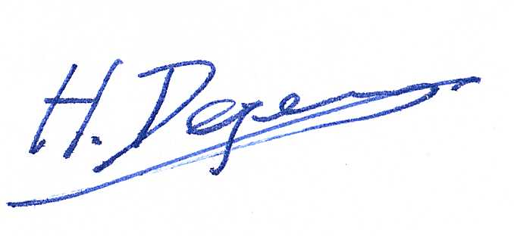  Professor Degens

Background
The University has introduced a quality management system for the governance of the acquisition, storage and use of human tissue.

This system will ensure that all work is carried out to the highest standard and that the University complies with the licensing obligations of the Human Tissue Act (HTA, 2004).

This SOP forms part of a suite of SOPs (MMUHTA_001 – MMUHTA_019) that support implementation of the quality management system and should be used as directed in conjunction with Manchester Metropolitan University’s HTA Code of Practice.

Purpose
The purpose of this SOP is to set out a standard template for the cleaning and decontamination of areas where material which falls under the Human Tissue Act (2004) has been used.

Human Tissue Definition
Any, and all, constituent part/s of the human body containing cells.

Scope (of this SOP)
All areas within Manchester Metropolitan University where relevant material is used and stored.

Related SOPs
SOPs MMUHTA_001 – MMUHTA_011 relating to the acquisition, storage, use and disposal of human tissue.

Responsible Personnel
- Principal Investigators
- Research Teams
- Technical staff

Procedure
It is the responsibility of Principal Investigators (PIs) to ensure that policies and procedures are adhered to, and appropriate risk assessments are developed for the cleaning and decontamination of areas where human tissue is used and stored.

These policies and procedures should comply with established good practice in the handling of biological samples. Additionally, it is the responsibility of PIs and technical support staff to ensure that appropriate personal protective equipment is available in areas where human tissue is used and stored.

Trained laboratory staff should undertake decontamination of areas where spillage has occurred. Routine cleaning will be undertaken in accordance with written local SOPs. Spilled and contaminated material should be separated and contained using disposable items of equipment that may be autoclaved.

To avoid cross contamination contaminated/infected material should be double sealed, labelled with appropriate hazard warning labels and taken to the autoclave unit for separate autoclaving. If appropriate, disposal should then be undertaken in accordance with SOP MMUHTA-007 (Disposal of Human Tissue).

Cleaning and decontamination of non-disposable equipment
Non-disposable equipment used for studies on human tissue should be decontaminated according to manufacturer’s instructions on completion of each procedure or experiment.

The recommended disinfectant for decontaminating surfaces, materials & samples, which have been in contact with human tissue, is a 1% Virkon™ solution followed by cleaning with 70% IMS.

Inducted and trained, technical services staff complete weekly spot checks for the John Dalton 3.05 storage facility. The spot checks are completed and signed off, a paper record kept in the room and every three months a digital copy is uploaded to the SharePoint, “Documents directory ‘Spot Checks 3.05a’”.

The spot check includes:
- Card reader access / egress check.
- Room temperature check.
- Freezer temperature check.
- Room lighting check.
- Freezers, cabinets & consent documents cupboard locked.
- Freezer key cabinet combination lock secured.
- Extension leads located in room (used for emergency power).
- SOP’s & Risk assessments folder in the room.
- PPE available (gloves, safety glasses, lab coats).
- Laminated sheets showing HT licence / Freezer storage / hazard signs.
- Freezers defrost check.

Weekly decontamination:

- All freezer surfaces / handles in JD 3.05a are decontaminated using 1% Virkon™ solution followed by cleaning with 70% Industrial Methylated Spirits.
- Floor surface is cleaned weekly using industrial cleaner.
- All sinks & surfaces are cleaned weekly using industrial cleaner.

Defrosting routine:
- The freezers are monitored weekly for excessive ice build-up. A thorough defrost is completed in line with our freezer annual service unless freezers are flagged as having excessive ice in the period between annual services.

Version Control

Version | Reason for change | Date
1.0 | N/A | 14th June, 2021
1.1 | A new SOP was added to the suite therefore writing changed to state ‘SOPs (MMU-HTA001 – MMU-HTA016)’ rather than SOPs (MMU-HTA001 – MMU-HTA015) | 25th November, 2022
1.2 | Changed writing to state ‘SOPs (MMU-HTA001 – MMU-HTA018)’ rather than SOPs (MMU-HTA001 – MMU-HTA016) | 30th January, 2023
1.3 | SOP edited to include more detail for cleaning and decontamination for the John Dalton 3rd floor storage facility. | 23rd February, 2023
1.4 | Author & Reviewer fields added to title table + changed writing to state ‘SOPS (MMUHTA_001 – MMUHTA_019)’ rather than SOPs (MMU-HTA001 – MMU-HTA018) + Minor grammatical & formatting changes | 2nd March, 2023

