STANDARD OPERATING PROCEDURE

Reference Number | MMUHTA_007
Title | Disposal of Human Tissue
Effective Date | 20th January 2023
Review Date | 2nd March 2023
Superseded Version Number & date | V1.4 2nd March 2023
Author | Glenn Ferris
Reviewer | Liam Hanson
Authorisation | Designated Individual  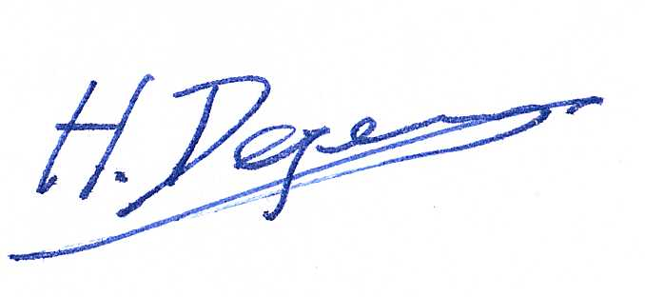  Professor Degens  Professor Degens

Background
The University has introduced a quality management system for the governance of the acquisition, storage, and use of human tissue.

This system will ensure that all work is carried out to the highest standard and that the University complies with the licensing obligations of the Human Tissue Act (HTA, 2004).

This SOP forms part of a suite of SOPs (MMUHTA_001 – MMUHTA_019) that supports implementation of the quality management system and should be used as directed in conjunction with Manchester Metropolitan University’s HTA Code of Practice.

Purpose
The purpose of this SOP is to set out a standard template for the disposal of material that falls under the Human Tissue Act (2004).

Definitions

Human Tissue
Any, and all, constituent part/s of the human body containing cells.

Scope (of this SOP)
The disposal of relevant material within Manchester Metropolitan University.

The procedures within this SOP relate to incineration disposal by Stericycle (https://www.stericycle.co.uk/en-gb) of gross and/or items containing relevant material on behalf of Manchester Metropolitan University. If there are special circumstances where the Principal Investigator wishes to use another disposal method, they should write a risk assessment and contact the DI for approval of the proposed method. In certain circumstances, such as disposal of liquid waste, or consumables containing liquid waste, chemical destruction with virkon (~1hr) could be utilised instead to then dispose the material in the biohazard bins located on 3rd floor near the goods lift.

Procedure
Relevant material must be disposed of in accordance with donor’s wishes if specified. The University has a contract with Stericycle for the removal and disposal of gross human tissue or items containing relevant material:
Account Manager: Mr Chris Westwood - 07931 747362
E-mail – cwestwood@srcl.com
Stericycle Indigo House, Sussex Ave, Leeds LS10 2LF

All gross human tissue for disposal must be transferred to Stericycle, who are contracted to dispose of Human Tissue on behalf of the University.

Once gross human tissue or items containing relevant material have been identified for disposal, either because it is no longer viable following use in experiments, or the project for which it has been stored has been completed, it should be transferred to Shelf 5 (bottom shelf) of -80⁰C Freezer ‘Hale Bopp’ (reserve freezer) in room T3.05a for temporary storage prior to disposal. Samples should be updated on the ItemTracker system, for samples due for destruction off-site the “Incineration – Off Site” method of disposal should be selected. Record of disposal must be updated on ItemTracker.

Unless otherwise stated, or material requires another form of containment (seek advice from DI or PDs) all relevant material (human tissue) should be placed in a yellow Biohazard bag (small).

The bag should be sealed and placed in the HT Biohazard bin located in the designated disposal shelf. This freezer is always locked, and all samples stored in this freezer will be sent for incineration. A key to the freezer is kept in a secure key box in John Dalton T3.05a. Access to the key box can be obtained from the Designated individual or Person Designated.

Disposal records must be recorded on the ItemTracker system by the PI / PhD students / HT user responsible for that material. An audit of the disposed samples will be carried out by the HTA working group every six months to ensure proper practice, cross checking samples marked as “Deleted” within ItemTracker to storage locations within the freezers.

Prior to Stericycle collecting the waste, trained technical staff will remove the to-disposed-off samples from the freezer, appropriately bagged and placed in a thirty-litre sealed red-lid container by the large incineration bins located in a controlled access area in the John Dalton building.

A copy of the signed waste consignment note from Stericycle should be forwarded to the appropriate technical staff who will allocate a unique identifier number. All samples that have been collected will be tagged as part of their disposal record to the appropriate transfer consignment note. The consignment note should be filed and retained for audit inspection. Consignment notes are on the ‘HT SharePoint – Consignment Notes folder’.

When tissue disposal is being undertaken at the end of a project the researcher in charge should inform the organisation from which the tissue originated in writing if required as part of the MTA. A copy of the letter should be filed as a part the project record and archived for audit purposes.

If the donor's own material is being returned at their request, then an MTA form should be completed.

Version Control

Version | Reason for change | Date
1.0 | N/A | 14 June, 2021
1.1 | Change in procedure | 23 March, 2022
1.2 | Change in procedure | 27 July, 2022
1.3 | A new SOP was added to the  suite therefore writing changed to state ‘SOPs (MMU-HTA001 – MMU-HTA016)’ rather than SOPs (MMU-HTA001 – MMU-HTA015) | 25th November, 2022
1.4 | Additional Information added to clarify steps for marking samples as disposed within the ItemTracker System + changed writing to state ‘SOPs (MMU-HTA001 – MMU-HTA018)’ rather than SOPs (MMU-HTA001 – MMU-HTA016) | 20th January, 2023
1.5 | Author & Reviewer fields added to title table + changed writing to state ‘SOPS (MMU-HTA_001 – MMUHTA_019)’ rather than SOPs (MMU-HTA001 – MMU-HTA018) + minor | 2nd March, 2023

