STANDARD OPERATING PROCEDURE

Reference Number | MMUHTA_010
Title | Collection and Recording of HTA Relevant Material
Effective Date | 23rd January 2023
Review Date | 2nd March 2023
Superseded Version Number & date | V1.2 2nd March 2023
Author | Liam Hanson
Reviewer | Liam Hanson
Authorisation | Designated Individual  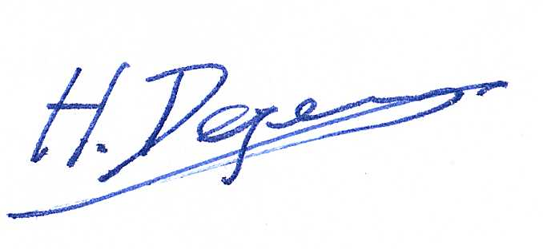  Professor Degens

Background
The University has introduced a quality management system for the governance of the acquisition, storage and use of human tissue.

This system will ensure that all work is carried out to the highest standard and that the University complies with the licensing obligations of the Human Tissue Act (HTA, 2004).

This SOP forms part of a suite of SOPs (MMUHTA_001 – MMUHTA_019) that support the implementation of the quality management system and should be used as directed in conjunction with Manchester Metropolitan University’s HTA Code of Practice.

Purpose
This SOP aims to set out a standard template for collecting and recording material that falls under the Human Tissue Act (2004).

Scope (of this SOP)
All Manchester Metropolitan University staff participating in work/projects involving relevant material

Requirements and Responsibility

- Principal Investigators (PIs) are responsible for ensuring that all human tissue users track the samples from the “Cradle to the Grave.” Evidence of traceability must be in place for all samples, from receipt to eventual disposal. It must be clear where the sample has come from, where the consent for the sample is stored, and in cases where no consent from is required, any Research Ethics Committee (REC) approvals or Material Transfer Agreements must be accessible.

- Relevant material is often collected during NHS REC approved research studies. Where appropriate and valid consent is obtained to store the samples for future studies.

- The Principal Investigator (PI), or student supervisor, is ultimately responsible for ensuring appropriate records are maintained for the samples collected, stored and used in their studies. It is the PI’s responsibility to ensure that at the end of a study, the samples are handled in line with the HTA Act 2004.

- The DI is responsible for assessing whether the tissue collection is suitable for acceptance under the HTA licence.

- PDs are responsible for assisting the DI by recording and auditing collections at ManMet and any additional tasks delegated by the DI as required to maintain compliance with the HTA standards.

- RKE is responsible for maintaining a central log of research projects and studies using human samples for research and keeping a record of ethics applications, e.g., to the University Ethics Committee or the NHS REC. Studies cannot commence unless a favourable ethical opinion has been received from an appropriate ethics committee.

Procedure
Researchers may apply to store human tissue samples under the research HTA licence. Storage under the licence requires compliance with the HTA Quality Management System.

Sample arrival:
- When samples arrive, researchers or sample receivers must complete the Sample Received Form in Appendix 1 and check for unexpected samples not noted on the associated MTA.
- Scan any associated Wayslips or transportation documentation.
- Place items in reserve freezer quarantine or appropriate secure storage location, e.g., locked slide cabinet.
- Contact the DI or a PD and ask for the Sample Received Form to be signed off.
- Completed Sample Received Form and Transportation documentation should be scanned and stored securely within SharePoint along with any associated MTA or Consent information.
- The PI or appropriate researcher are then required to add the samples to the Itemtracker sample storage system in a timely fashion.

Sample Usage
When researchers remove samples from a designated human tissue storage area, this should be recorded in the Itemtracker storage system. A record needs to be made for each sample removed. If in use (e.g., histology or DNA isolation) or to be disposed of, this should be recorded in Itemtracker, along with the generation of any daughter samples.

Possible reasons and relevant field selected within Itemtracker:

- Incorrect Upload – To be used if a sample has been incorrectly uploaded onto the Itemtracker database.
- Adverse Event – Denoting if a sample has been lost because of an adverse event, including but not limited to freezer failure, power failure, on-site fire or sample degradation.
- Consent Withdrawn – To be used when a participant has withdrawn consent, samples are subsequently removed from Itemtracker and destroyed.
- Sample Disposed > Processed – Denoting samples disposed of via sample processing, e.g., DNA extracted.
- Sample Disposed > Chemical Destruction (On-Site) – Denoting samples destroyed on-site via chemical destruction, i.e., immersion in virkon, ethanol, etc.
- Sample Disposed > Incineration (Off-Site) – Denoting samples destroyed off-site through Stericycle (see SOP MMUHTA_007).

Sample Disposal
If the sample is being disposed of as clinical waste, it needs to be transferred to the -80ºC temporary storage freezer in room T3.05 prior to disposal as indicated in SOP MMUHTA_007 (Disposal of Human tissue).

GLOSSARY OF TERMS:
- DI: Designated Individual
- HT Act: Human Tissue Act
- HTA: Human Tissue Authority
- NHS REC: National Health Service Research Ethics Committee
- PD: Person Designated
- RKE: Research Knowledge Exchange
- SOP: Standard Operating Procedure
- Human Tissue: Any and all constituent part/s of the human body containing cells (relevant material)

Appendix 1: Sample Received Form

Human Biological Sample Receipt Form.docx

Version Control

Version | Reason for change | Date
V1.0 | N/A | 14th June, 2021
V1.1 | A new SOP was added to the suite therefore writing changed to state ‘SOPs (MMU-HTA001 – MMU-HTA016)’ rather than SOPs (MMU-HTA001 – MMU-HTA015) | 25th November, 2022
V1.2 | Revised version to include sample arrival procedure + changes in writing to indicate new SOPs were added in the suite (MMU-HTA001 – MMU-HTA018) | 23 January, 2023
V1.3 | Author & Reviewer fields added to title table + changed writing to state ‘SOPs (MMUHTA_001 – MMUHTA_019)’ rather than SOPs (MMU-HTA001 – MMU-HTA018) + minor grammatical & formatting changes | 2nd March, 2023

