STANDARD OPERATING PROCEDURE

Reference Number | MMUHTA_011
Title | Issue and Return of Human Tissue
Effective Date | 30th January 2023
Review Date | 3rd March 2025
Superseded Version Number & date | V1.2 3rd March 2023
Author | Sarika Ellul
Reviewer | Liam Hanson
Authorisation | Designated Individual  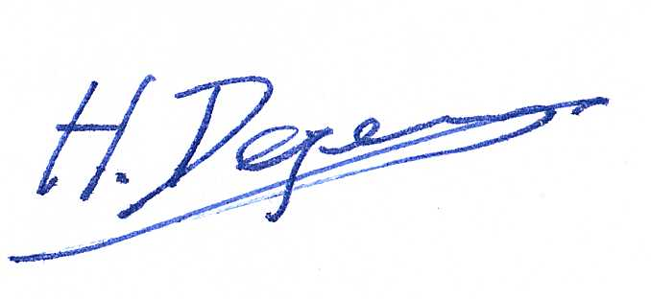  Professor Degens

Background
The University has introduced a quality management system for the governance of the acquisition, storage, and use of human tissue.

This system will ensure that all work is carried out to the highest standard and that the University complies with the licensing obligations of the Human Tissue Act (HTA, 2004).

This SOP forms part of a suite of SOPs (MMUHTA_001 – MMUHTA_019) that support implementation of the quality management system and should be used as directed in conjunction with Manchester Metropolitan University’s HTA Code of Practice.

Purpose
The purpose of this SOP is to set out a standard template for correct issue and return of material that falls under the Human Tissue Act (2004).

Definitions

Human Tissue
Any, and all, constituent part/s of the human body containing cells.

Scope (of this SOP)
All Manchester Metropolitan University staff participating in work/projects involving human tissue.

Responsibility
Those leading a research project (Principal Investigators or Chief Investigators) are responsible to make sure that all users of human tissue track the samples that they are using from receipt and/or collection to destruction and disposal. This means that they are responsible for recording the samples correctly onto Manchester Metropolitan University’s sample tracking system. Those leading a research project are responsible to make sure that users record eventual disposal for traceability.

Procedure
When investigators remove samples from a designated human tissue storage area, a record needs to be made for each sample used within an electronic documentation system.

Designated reasons for removal are:

- Clinical Waste (human tissue only)
- General clinical waste (for incineration)
- Returned to tissue bank
- Returned to donor/family
- Adverse event
- Used in Experiment
- Consent withdrawn
- Redundant Sample (no justification for holding)
- Degraded sample
- Project ended (Sample(s) project specific

If the sample is being disposed of as clinical waste as specified in the SOP MMUHTA_007 (Disposal of human material). It needs to be placed into the -20⁰C freezer in room T3.05 designated for disposal and recorded as being disposed of.

Version Control

Version | Reason for change | Date
1.0 | N/A | 14th June, 2021
1.1 | A new SOP was added to the suite therefore writing changed to state ‘SOPs (MMU-HTA001 – MMU-HTA016)’ rather than SOPs (MMU-HTA001 – MMU-HTA015) | 25th November, 2022
1.2 | Changed writing to state ‘SOPs (MMU-HTA001 – MMU-HTA018)’ rather than SOPs (MMU-HTA001 – MMU-HTA016) | 30th January, 2023
1.3 | Author & Reviewer fields added to title table + changed writing to state ‘SOPS (MMUHTA_001 – MMUHTA_019)’ rather than SOPs (MMU-HTA001 – MMU-HTA018) + minor grammatical & formatting changes | 3rd March, 2023

