STANDARD OPERATING PROCEDURE

Reference Number | MMUHTA_012
Title | Labelling of Human Tissue Samples
Effective Date | 30th January 2023
Review Date | 3rd March 2025
Superseded Version Number & date | V1.2 3rd March 2023
Author | Sarika Ellul & Liam Hanson
Reviewer | Garry Pheasey
Authorisation | Designated Individual  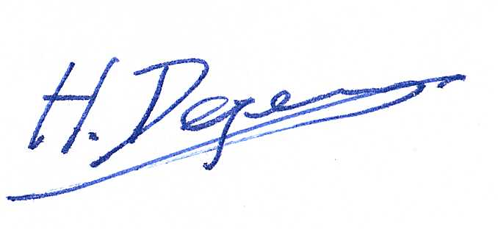  Professor Degens

Background
The University has introduced a quality management system for the governance of the acquisition, storage and use of human tissue.

This system will ensure that all work is carried out to the highest standard and that the University complies with the licensing obligations of the Human Tissue Act (HTA, 2004).

This SOP forms part of a suite of SOPs (MMUHTA_001 – MMUHTA_019) that support implementation of the quality management system and should be used as directed in conjunction with Manchester Metropolitan University’s HTA Code of Practice.

Purpose
The purpose of this SOP is to set out a standard template for correct labelling of material that falls under the Human Tissue Act (2004).

Responsibilities
Principle Investigators are responsible for correct labelling of human tissue samples.
Designated Individual and Persons Designated are responsible for ensuring labelling procedures are followed.

Definitions

Human Tissue
Any, and all, constituent part/s of the human body containing cells.

Scope (of this SOP)
The labelling of all relevant material within Manchester Metropolitan University.

Procedure
Any sample stored must be labelled with a unique identifier code that makes it possible to link the sample back to the associated consent form and ethics application, material transfer document or NHS ethics approval.
Suitable training will be provided by the Designated Individual, Person Designated or another competent person, explaining:
- How to label aliquots?
- How to affix a barcode label?
- Labelling procedure when transferring samples to a new container?
- Labelling procedures during processing/using samples?

Sample label information is accurately recorded on the sample traceability spreadsheet located on the HT SharePoint.

The samples must be stored in a designated HTA area; any samples stored in undesignated areas for longer than seven days will be destroyed.

Labelling of Samples to be Transported (see SOP MMUHTA_004) to other institutions.
The tissue should be packed into a sealed container labelled with the following information:

Human Tissue Sample
Sample Reference Number:
Tissue Type:
Details of medium/preservative if applicable:
Date of packing:
UN 3373 warning label

If applicable, it should be labelled with hazard warning labels relating to the medium/preservative and the approved human-tissue sample hazard-warning label – UN 3373.

Containers and labels for human tissue transfer can be purchased from general laboratory suppliers by technical support staff.

Labelling of Samples for Disposal of Human Tissue (see SOP MMUHTA_007).
Once human tissue has been identified for disposal, either because it is no longer viable following use in experiments, or the project for which it has been stored has been completed, it should be transferred to the -20⁰C temporary storage freezer in room John Dalton T3.05 prior to disposal. Record of disposal must be updated using an appropriate sample traceability system (spreadsheet or nominated system).

Put the samples in a yellow bag (available from PDs) for disposal of the human tissue and label the bag with the following information:
- Human Tissue Samples for Disposal
- Project Reference Number
- Sample Reference Number(s)
- Custodian
- Contact Details of Custodian

After labelling and prior to appointed disposal contractors collecting the waste, technical staff will remove samples from the freezer to the appropriate clinical incineration bin and a consignment note is given by the disposal contractor.

Copy of the signed waste consignment notes from the University appointed contractors should be forwarded to the appropriate technical staff (Carol Hardbattle) and checked for accuracy. All samples that have been collected will be tagged as part of their disposal record and transfer consignment. The consignment note is filed in the ‘consignment folder’ on the HT SharePoint and retained for audit inspection.

Version Control

Version | Reason for change | Date
1.0 | N/A | 14th June 2021
1.1 | A new SOP was added to the suite therefore writing changed to state ‘SOPs (MMU-HTA001 – MMU-HTA016)’ rather than SOPs (MMU-HTA001 – MMU-HTA015) | 25th November, 2022
1.2 | Changed writing to state ‘SOPs (MMU-HTA001 – MMU-HTA018)’ rather than SOPs (MMU-HTA001 – MMU-HTA016) | 30th January, 2023
1.3 | Author & Reviewer fields added to title table + changed writing to state ‘SOPS (MMU-HTA_001 – MMUHTA_019)’ rather than SOPs (MMU-HTA001 – MMU-HTA018) + minor grammatical & formatting changes | 3rd March, 2023

