STANDARD OPERATING PROCEDURE
Reference Number | MMUHTA_013
Title | Freezer Failure
Effective Date | 30th January 2023
Review Date | 3rd March 2025
Superseded Version Number & date | V1.2 3rd March 2023
Author | Glenn Ferris
Reviewer | Liam Hanson
Authorisation | Designated Individual  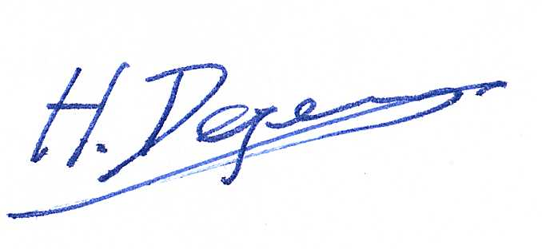  Professor Hans Degens

Background
The University has introduced a quality management system for the governance of the acquisition, storage, and use of human tissue.
This system will ensure that all work is carried out to the highest standard and that the University complies with the licensing obligations of the Human Tissue Act (HTA, 2004).
This SOP forms part of a suite of SOPs (MMU_HTA001 – MMU_HTA019) that support implementation of the quality management system and should be used as directed in conjunction with Manchester Metropolitan University’s HTA Code of Practice.

Purpose
The purpose of this SOP is to set out a process to be followed in the event of the failure of a freezer which contains material that falls under the Human Tissue Act (2004).
Definitions

Human Tissue
Any, and all, constituent part/s of the human body containing cells.

Scope (of this SOP)
Failures of freezers storing relevant material in Manchester Metropolitan University including responsible personnel, operational procedures, gaining access to the building out of hours and reporting the event.

Purpose
This SOP is to ensure that in the event of a freezer failure the integrity of all relevant material is maintained, and freezer failure is dealt with in a timely manner, as far as reasonably practicable.

Responsible Personnel
Designated individual (DI) – responsible for implementation of this procedure and making sure that all staff on the human tissue emergency call-out list are fully aware of procedures in this SOP and trained appropriately.
Persons designated (PD) – responsible for:
- Reviewing/updating this procedure at least every two years
- Providing training to staff on the human tissue emergency call-out list – which is kept and maintained by the PDs.
- The system is checked and calibrated every year by Tutela
Technical Services – responsible for ensuring freezers are maintained appropriately.
Facilities – carrying out PAT testing according to current regulations and maintaining back-up generators.
Security – (out of normal business hours only), assisting with access to John Dalton tower if requested, from any persons on the human tissue emergency call-out list.

Procedure
In the event a fault is detected by the automatic dialler the actions in the freezer fault response chart (Figure 1) will be carried out.
In the event of power failure to the human tissue freezers at MMU, or associated building, refer to the following documents, located on the Human Tissue SharePoint (Figure 2).
- ‘Disaster Recovery Instruction’
- ‘Information on MTS Cryo Stores Disaster recovery procedure’
- ‘The expectations of the Clients & MTS in a Disaster Recovery.
Link to the HTA repository: Disaster Recovery folder

Red Socket Failure Procedure
If the power failure is only present in T3.05a due to the failure of red sockets, locate the extension leads in T3.05a and find a viable source of electricity. Proceed to unplug the units from the red socket, plug them in extension leads and switch on the socket providing power to the extension lead. The emergency electrician should then be contacted to fix the issue with the red sockets. Once power is restored to the red sockets, transfer the units’ plugs back to their original red socket.

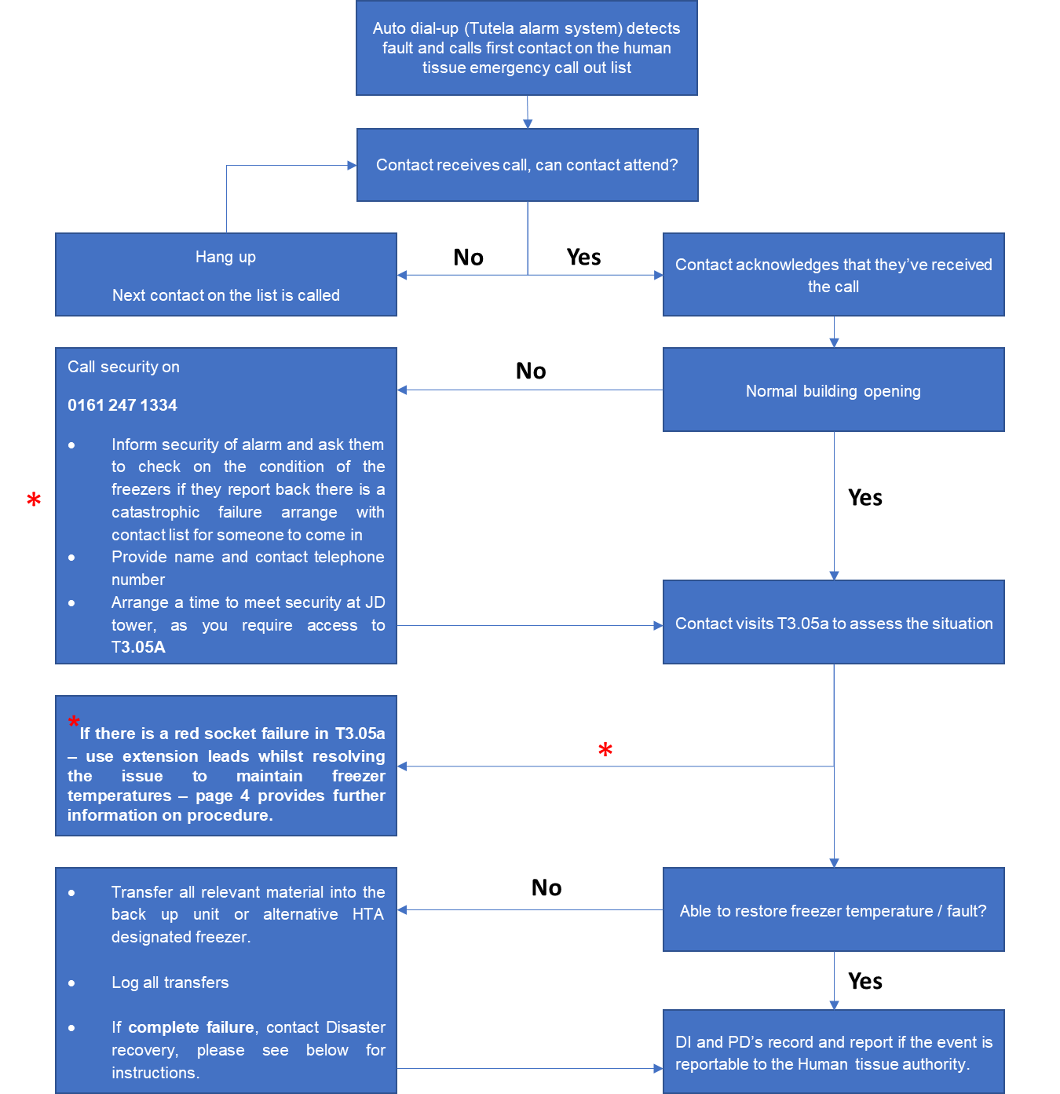

Figure 1 Freezer Failure Response Chart
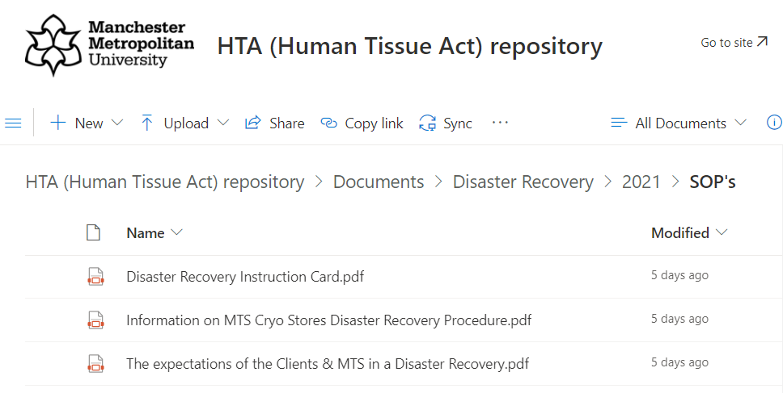

Figure 2 Disaster Recovery Documentation Folder

Version Control
Version | Reason for change | Date
1.0 | N/A | 14th June, 2021
1.1 | Issues with red sockets + new Tutela system + A new SOP was added to the suite therefore writing changed to state ‘SOPs (MMU-HTA001 – MMU-HTA016)’ rather than SOPs (MMU-HTA001 – MMU-HTA015) | 21st November, 2022
1.2 | Changed writing to state ‘SOPs (MMU-HTA001 – MMU-HTA018)’ rather than SOPs (MMU-HTA001 – MMU-HTA016) | 30th January, 2023
1.3 | Author & Reviewer fields added to title table + changed writing to state ‘SOPS (MMUHTA_001 – MMU-HTA_019)’ rather than SOPs (MMU-HTA001 – MMU-HTA018) + minor grammatical & formatting changes | 3rd March, 2023

