STANDARD OPERATING PROCEDURE
Reference Number | MMUHTA_016
Title | Collection Of Plasma from Whole Blood to Render it Acellular
Effective Date | 30th January 2023
Review Date | 3rd March 2025
Superseded Version Number & date | V1.1 3rd March 2023
Author | Glenn Ferris
Reviewer | Liam Hanson
Authorisation | Designated Individual  Professor Degens

Background
The University has introduced a quality management system for the governance of the acquisition, storage and use of human tissue.
This system will ensure that all work is carried out to the highest standard and that the University complies with the licensing obligations of the Human Tissue Act (HTA, 2004).
This SOP forms part of a suite of SOPs (MMUHTA_001 – MMUHTA_019) that support the implementation of the quality management system and should be used as directed in conjunction with Manchester Metropolitan University’s HTA Code of Practice

Purpose
This document describes the process for the collection of human plasma from whole blood to render it acellular and Non-HTA relevant.

Scope
Collection of Blood Plasma, to preserve plasma for biobanking studies.

Requirements:
Equipment:
- Appropriate PPE (gloves, lab coat and lab glasses)
- Centrifuge with swinging bucket rotor
- Class II Biosafety Cabinet Hood
- Pipettes
- -80°C Freezer

Materials:
- Vacutainer Blood Collection Tubes
- Sterile pipette tips
- Sterile 1.5ml – 2ml storage tubes
- Storage box to fit -80C freezer (13.3 × 13.3 cm square bases).

Method:
- Lab coats and disposable gloves must be worn by staff and students when handling body fluids or materials which may have been in contact with any bodily fluids. Particular care should be taken to cover any cuts on the hands with waterproof plasters. The use of a Class II safety cabinet is optional but recommended when working with blood products.
- After collection, gently mix the blood by inverting the tube 8 to 10 times. Store vacutainer tubes upright until centrifugation. Blood samples should be centrifuged within four hours of blood collection and cooled in a bucket of ice.
- Centrifuge blood samples in a horizontal rotor (swing-out head) for 10 minutes at 1500g at 4C (please see appendix 1).
- After centrifugation, the plasma layer will be at the top of the tube. Mononuclear cells and platelets will be in a whitish layer, called the “buffy coat”, just under the plasma and above the red blood cells (additional processing of these cell fractions is optional. Long-term storage of these cellular fractions is HTA-relevant human tissue unless further processed).
- Carefully collect the plasma layer with an appropriate transfer pipette without disturbing the buffy coat layer. Pipette the plasma into appropriate-sized aliquots in labelled tubes (e.g., Sterile 1.5ml – 2ml storage tubes). Close the lids or caps tightly and place them on ice. This process should be completed within 1 hour of centrifugation.
- Place all aliquots upright in a storage box and rack them in -80°C freezer.
  - Samples must receive a unique identification number (ID) that anonymously identifies them as belonging to a particular ethics-approved study.
  - Record the date and time of blood collection and the volume of aliquots prepared.
  - Note any variations or deviations from the SOP, problems, or issues.
- Vacutainer Blood Collection Tubes containing unwanted waste should be recapped and placed in a clinical waste bin for disposal by a registered clinical waste provider by incineration (use yellow-lidded bins).
- Liquid waste can be poured into a pot containing 1% Virkon and stored and neutralised overnight before flushing down the drain with plenty of running water.

Appendix
Sysmex analysis of plasma samples using different centrifugation speeds.

Using a Sysmex XP-300™ Automated Haematology Analyzer
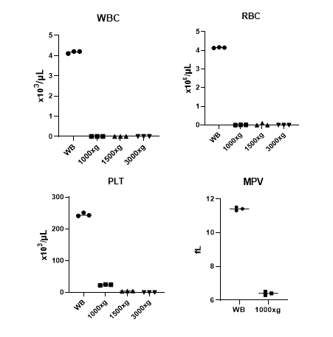
Full blood counts were performed on whole blood (WB), or plasma centrifuged at 1000g, 1500g or 3000g for 10 minutes.

Results show:

1000g completely removed red blood cells (RBCs) and white blood cells (WBCs)
There were a few remaining particles measured as platelets, however, the size of these particles measured by mean platelet volume (MPV) was half that of platelets, suggesting that they are vesicles or debris, not cells.
1000g for 10 minutes is therefore sufficient to remove cells from plasma, and a standard SOP of 1500g is more than adequate speed to render plasma acellular and Non-HTA relevant.

Version Control

Version | Reason for change | Date
1.0 | N/A | 15th November, 2022
1.1 | Changed writing to state ‘SOPs (MMU-HTA001 – MMU-HTA018)’ rather than SOPs (MMU-HTA001 – MMU-HTA016) | 30th January, 2023
1.2 | Author & Reviewer fields added to title table + changed writing to state ‘SOPS (MMU-HTA001 – MMU-HTA019)’ rather than SOPs (MMU-HTA001 – MMU-HTA018) + minor grammatical & formatting changes | 3rd March, 2033

