STANDARD OPERATING PROCEDURE

Reference Number | MMUHTA_019
Title | HTA SOP Change Control
Effective Date | 2nd March 2023
Review Date | 2nd March 2025
Superseded Version Number & date | New SOP
Author | Alison Lloyd  Research Ethics and Governance Manager
Authorisation | Designated Individual  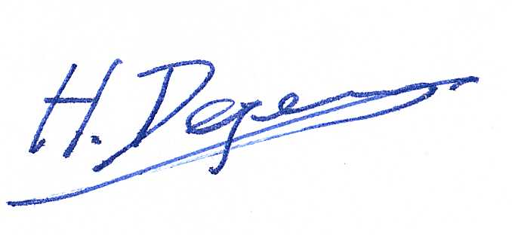  Professor Hans Degens

Background
The University has introduced a quality management system for the governance of the acquisition, storage, and use of human tissue.

This system will ensure that all work is carried out to the highest standard and that the University complies with the licensing obligations of the Human Tissue Act (HTA, 2004).

This SOP forms part of a suite of SOPs (MMUHTA_001 – MMUHTA_019) that support implementation of the quality management system and should be used as directed in Manchester Metropolitan University’s HTA Code of Practice.

Purpose
The purpose of this SOP is to describe the procedure for controlling planned changes relating to processes, practices, facilities, and systems involved in the acquisition, storage, use and disposal of human relevant material which falls under the Manchester Metropolitan University’s Human Tissue Act (2004) licence.

Responsibilities
Manchester Metropolitan University’s Designated Individual (DI) is responsible for the control of planned changes to facilities, systems, processes, and practices that may impact on activities which fall under the University Human Tissue Act (HT Act) Licence.

Individuals proposing to change the facility, system, process, or practice that may impact on the University’s Research HT Act licenced activity must discuss with the persons designated (PDs) and DI a suggested change before any change is made.

The DI is responsible for ensuring that any planned change to University HT Act licensed systems or processes do not conflict with any other part of the existing quality management system.

The PDs on behalf of the DI are responsible for the review and approval of all change requests relating to activities involving HTA Licensable material.

Procedure
In case of other than editorial changes, a change risk form will be completed by the DI and the PDs, with a member of the Research Ethics and Governance team, considering the perceived need for change, feasibility, risk, impact (such as potential training requirements) and any other information.

The changes will then be taken to the Human Tissue Act Committee for discussion and approval to implement. Where the decision is made not to make the change requested, the requester will be notified via email by the DI or a PD. Where a change request will potentially have a wider impact on the University, this will be taken to the Research Ethics and Governance Committee for discussion.

All individuals registered as working within relevant material under the University HTA licence, will be notified of the change by email. Where further training is needed as a result of the change these will be provided and delivered in accordance with MMUHTA_008.

When all activity associated with the implementation of the change have been completed, the Change Risk Form (CRF) will be closed and stored in the HTA master file.

Version Control

Version | Reason for change | Date

APPENDIX 1: Manchester Metropolitan University
Human Tissue Act Change Request Form (CRF) [Request number:]

System Description
Reason for and overview of change requested
Associated systems or documents affected by the change  *any change that impact activity under the Human Tissue Act Licence must be approved by the DI | Impact of change: | If yes, briefly describe
 |  | Yes | No
 | Health and Safety | ☐ | ☐
 | Activities Under the HTA Licence | ☐ | ☐
 | Quality System Procedures | ☐ | ☐
 | Product / Sample Quality | ☐ | ☐
 | Operational Processes | ☐ | ☐
 | Equipment or Systems | ☐ | ☐
 | Facility Infrastructure | ☐ | ☐
 | Staff Training | ☐ | ☐
 | Other | ☐ | ☐
Activity required to implement the change  (insert rows as required) | Actions | Assigned to: |  | Complete/ Evidence/Outcome | Date:
Change raised by: | Name: | Signature: |  |  | Date:
Change approved by (PD) | Name: | Signature: |  |  | Date:
Implementation approved by: | Name: | Signature: |  |  | Date:
Implementation verified by (DI): | Name: | Signature: |  |  | Date:
 | Remarks:

